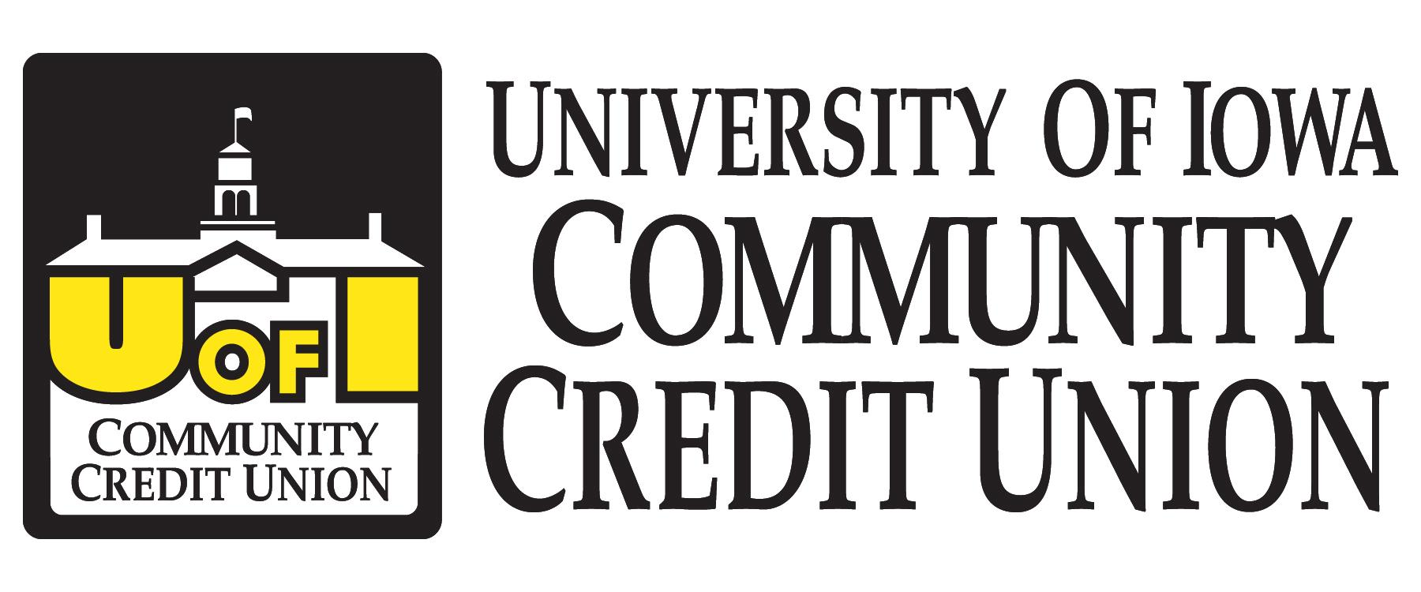
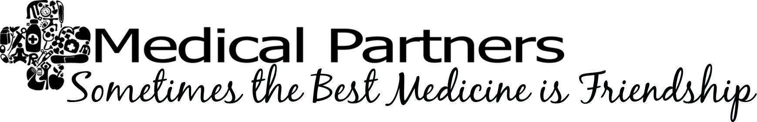

July 20, 2013

Welcome to Medical Partners’ Annual Welcome Brunch, sponsored by The University of Iowa Community Credit Union. For over 70 years, Iowa Medical Partners has existed as a nonprofit organization for the spouses/partners and families of physicians, dentists, and medical students training at the University of Iowa. The primary goal of Iowa Medical Partners is to serve and support these families through our many interest groups, social functions,and philanthropy. We hope that through Iowa Medical Partners, you can discover the same sense of community and friendship that we strive to provide each year.

For those of you who are returning members, we are excited that you are joining us for another action-packed year. For our new and potential members, we want to welcome you to the area and help you connect with others in your situation. It can be difficult adjusting to the demands of your spouse’s new schedule, and it is often helpful knowing and getting together with people who are going through the same things.

Please check our website for updates and upcoming events: www.iowamedicalpartners.com

***Guess how many are in the jar for a chance to take it home!**

9:00 Welcome: Ali Holt, President

9:10 Thank You to UICCU/get to know you game: Tina Willet, Marketing Director

~ Brunch served by the University Club ~

10:00 Keynote Speaker: Richard Saunders, Dept. of Human Resources at U of I

10:45 Introduction of 2013 Officers:

President: Ali Holt
Vice-President: Katie Wittry
Treasurer: Ali Jones
Secretary/Pulse Editor: Chelsea Cheney
Website Editor: Missa Uhlman
Marketing Director: Tina Willet

11:00 Door Prizes

11:15 Introduction of Officers and information about committees:
Children’s Activities: Brittany Houwen & Corrinne Gore
Entertainment Club: Emily Miska
S.O.S.: Katie Deem
Playgroup: Allie Buckwalter
Philanthropy: Amy Nicholson & Abby Carpenter

End with final Door Prizes- THANK YOU for coming!

Welcome Brunch Contributors

Iowa Medical Partners would like to express our sincere thanks and appreciation to all of the businesses that so generously donated today’s wonderful door prizes. Please consider shopping at the following locations and take a minute to thank them for their continued support.

University of Iowa Community Credit Union

Catherine’s Jimmy Jack’s Rib Shack

Core Fitness Downward Dog Yoga

Jimmy John’s University of Iowa

Just Duckie Blankies Basta

Starbucks- Iowa City Atlas

Stella Europa Salon & Spa

Molly’s Cupcakes Blackstone

We Run Coral Ridge Mall

Trade Secret Le Reve

Fencerow Designs Eggy’s

Iowa Children’s Museum New Pioneer Co-op

South Slope Community Center Tompkin’s Lawn Service

South Slope Cooperative Blaze Hair Salon

Tutu U Studio 889

Molly Eken’s Mittens Capanna

East-West School of Massage Mail, Print & More

Iowa Gym-Nest Sports Clips- North Liberty

Scentsy Ghurtie’s

Flash Digital Portraits Giardiniera Chicago Kitchen

*Special thanks to Robyn Rasmussen of Ruby Ellen Photography for photographing today’s event!*

