Adding a Website Ad
Go to www.weebly.com  Login & Password are the same as the IMP Gmail account. | 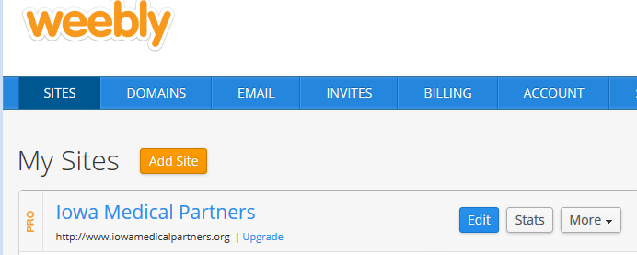
- Click on “Store” and then  - “Orders” to verify that the property listing has been paid for. If it has, go ahead and post it. If not, I send them an e-mail like this:  Hi Susanne,  Thanks for submitting your advertisement for the Iowa Medical Partners website!  I received your ad logo and business information, but it doesn't look like your payment has gone through.  Please visit our website at: www.iowamedicalpartners.org/advertise.html to submit your payment through PayPal. Once we've received your payment, I'll get your ad posted ASAP!  Please let me know if you have any questions, or if there is anything else that I can do for you.  Thanks,  Missa Uhlman  Iowa Medical Partners | 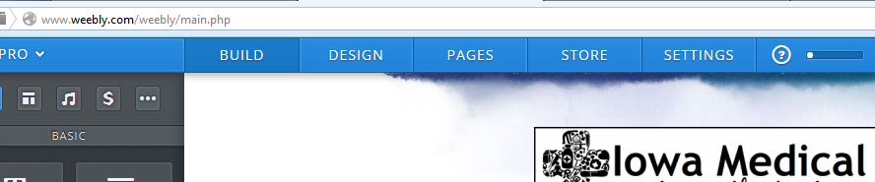  1  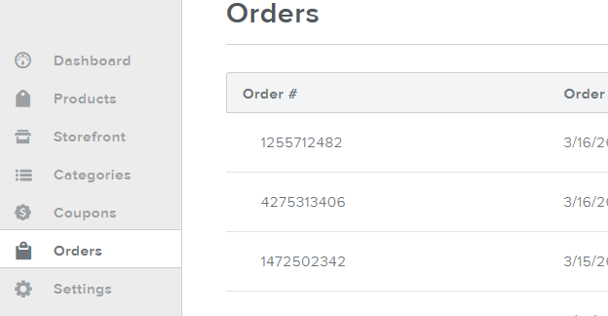  2
- Click on “Build”. This will take you to the homepage.

- Scroll all the way to the bottom of the page. There are eight ad spaces ready to go, which should be more than enough for the week that I’m gone!

- Download the ad logo that was e-mailed to you.

- Select an available ad space and upload the ad logo from your computer.

- Once you have uploaded the ad logo and the image comes up in the correct place, click on it.  - Click on “Link” in the black box.  - Copy and paste the business web address into the highlighted bar under “Website URL”.  - Check the box that says “Open link in new window.  - Click “Save”  - Click “Publish”. | 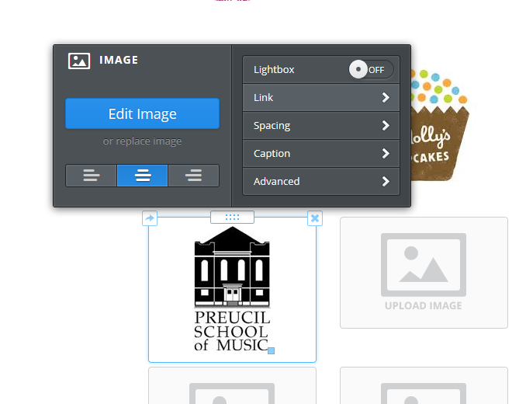  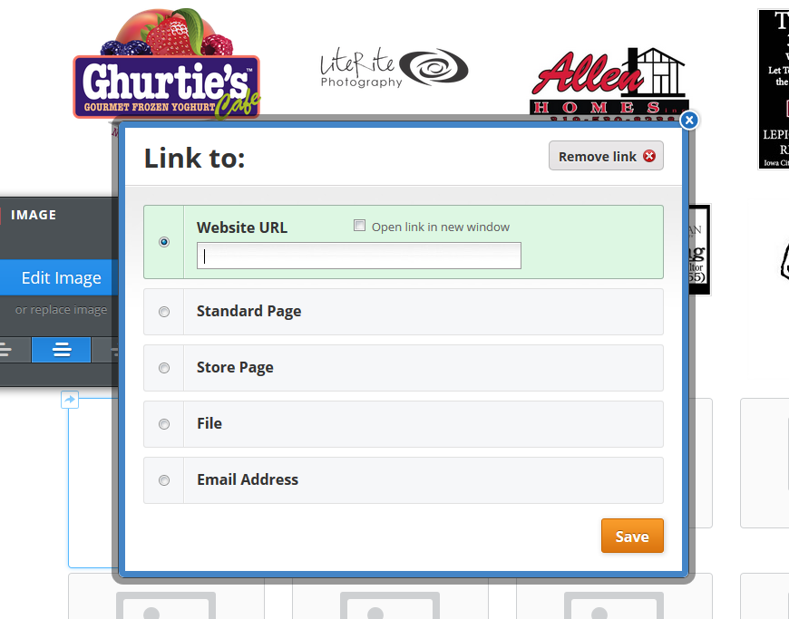  32  2  1  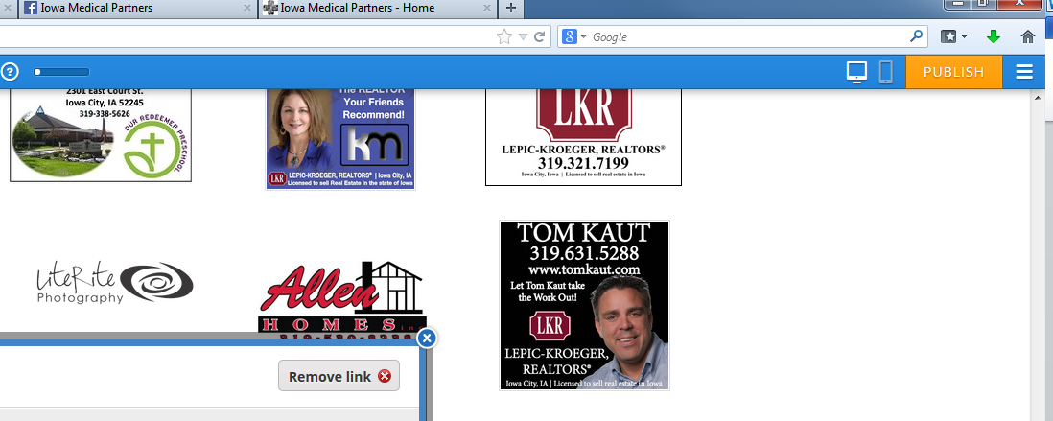
For all ads successfully submitted and posted, send a confirmation e-mail that says something like this:

Hi William,

Thank you for advertising with Iowa Medical Partners! I have just posted your ad logo and link to our homepage.
Please let me know if you have any questions, or if there is anything else that I can do.

Thanks,
Missa Uhlman
Iowa Medical Partners

