Adding a Property Listing
Go to www.weebly.com
- Login & Password are the same as the IMP Gmail account.
Click on “Iowa Medical Partners” website title to get into the Editor view. | 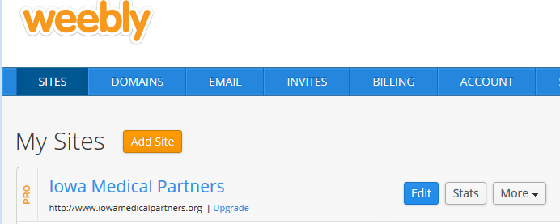
- Click on “Store” and then  - “Orders” to verify that the property listing has been paid for. If it has, go ahead and post it. If not, I send them an e-mail like this:  Hi Susanne,  Thanks for submitting your property to list on the Iowa Medical Partners site!  I received your property information, but it doesn't look like your payment has gone through.  Please visit our website at: http://www.iowamedicalpartners.org/post-properties.html to submit your payment through PayPal. Once we've received your payment, I'll get your property posted ASAP!  Please let me know if you have any questions, or if there is anything else that I can do for you.  Thanks,  Missa Uhlman  Iowa Medical Partners | 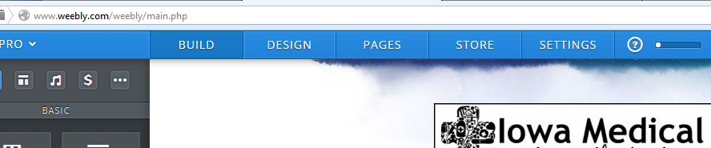  1  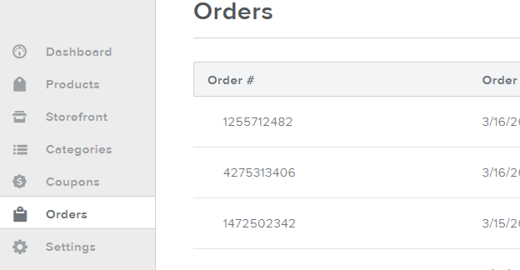  2
- Click on “Pages”  - Scroll down the list on the left side of the screen all the way to the bottom.  - Select either “SALE” Listings or “RENT listings”  - Click the “Save & Edit” button | 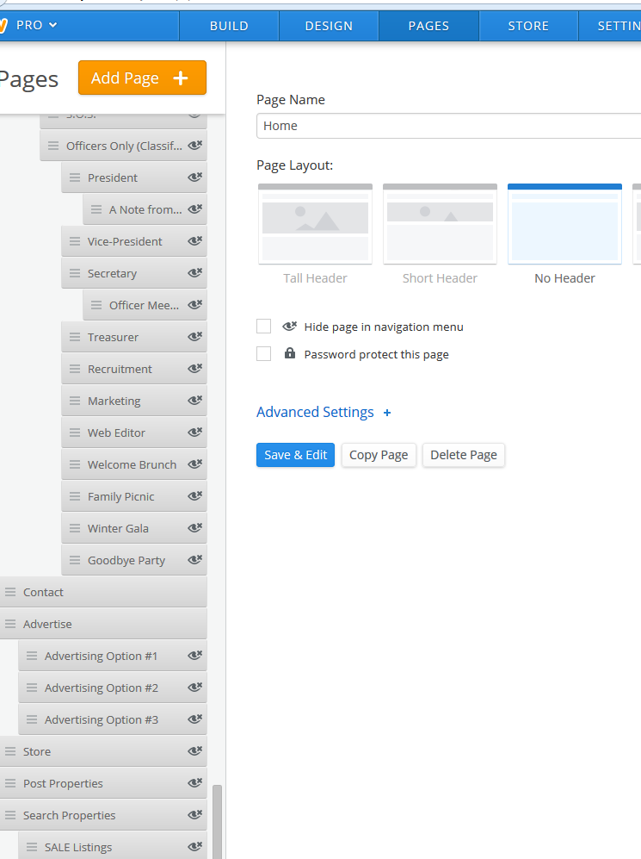  3  2  1
IF THE SELLER/RENTER SENT AN E-MAIL WITH LISTING INFO SHEET & PHOTOS ATTACHED:
In E-Mail:
- Forward e-mail to me at missa.uhlman@gmail.com so I can keep it archived.

- Download all photos and listing info sheet to your computer.

- Either take a screen shot of the listing info sheet and save
as a JPG image file, or just keep it pulled up so you can
cut/paste info from there onto the property ad.

In Weebly:  - Click on “New Post”  - Drag in “Columns” to the body of the post  - Drag “Image” to left column  - Drag “Text” to right column  - Drag “Read More Break” below columns  - If you saved the listing sheet as a JPG:  Drag “Image” below “Read More Break”  --OR—  If you are going to cut/paste the info from the listing sheet  Drag “Text” below “Read More Break”  - Drag “Slideshow” below “Image” / “Text” (whatever you dragged in above)  - Select “Thumbnails on Bottom” option.  - Click “Continue”.  - A window will open where you can upload the property photos to make a slideshow. Arrange photos if necessary (so bathroom isn’t the first picture, etc.)  - Click “Save”  - Click the “Upload Image” block in the left column and upload a feature image for the property.  - Click the “Text” block in the right column and type this: “For complete listing information and photos, click link below.”  - Either upload the JPG image of the listing sheet to the “Image” block below the “Read More Break” or cut/paste info from the listing sheet to the “Text” block below the “Read More Break”.  - Copy the listing title into the “Post Title” line at the top.  - Select appropriate # of bedrooms under “Categories” on the right.  - Click “Publish Live”. | 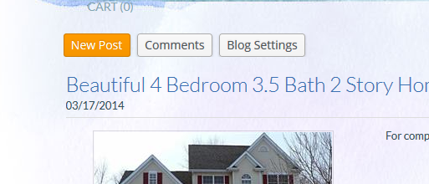  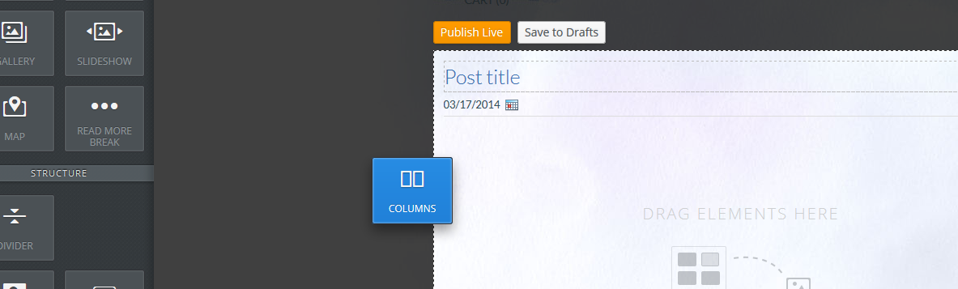  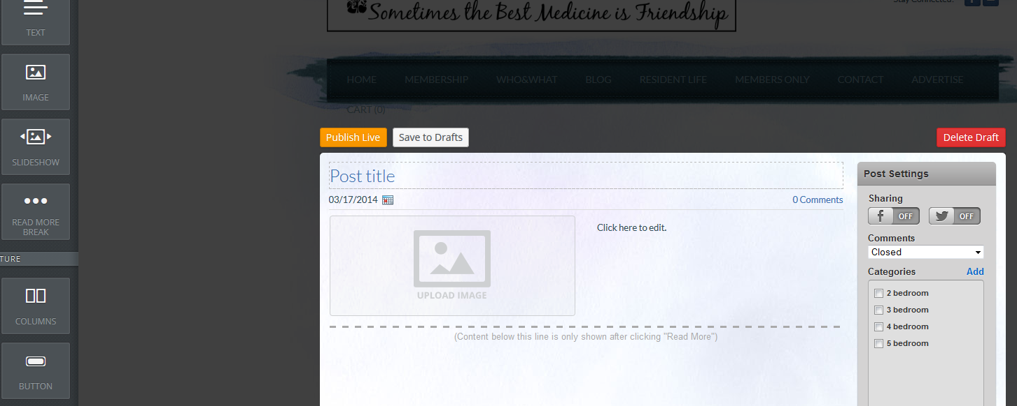  4  3  2  1  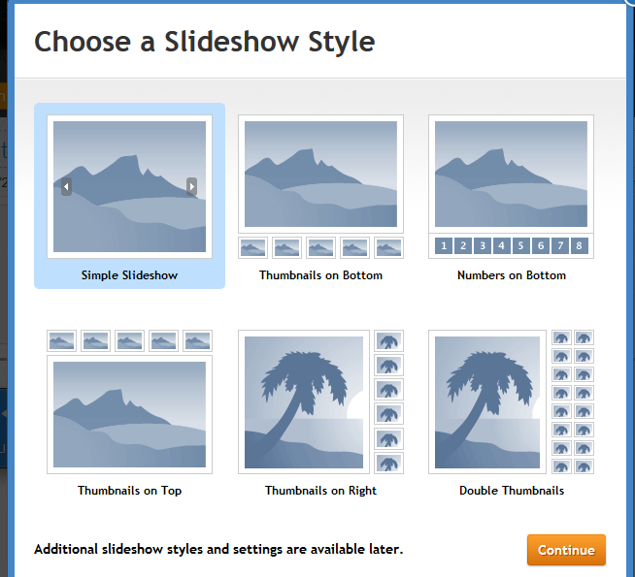  2  1  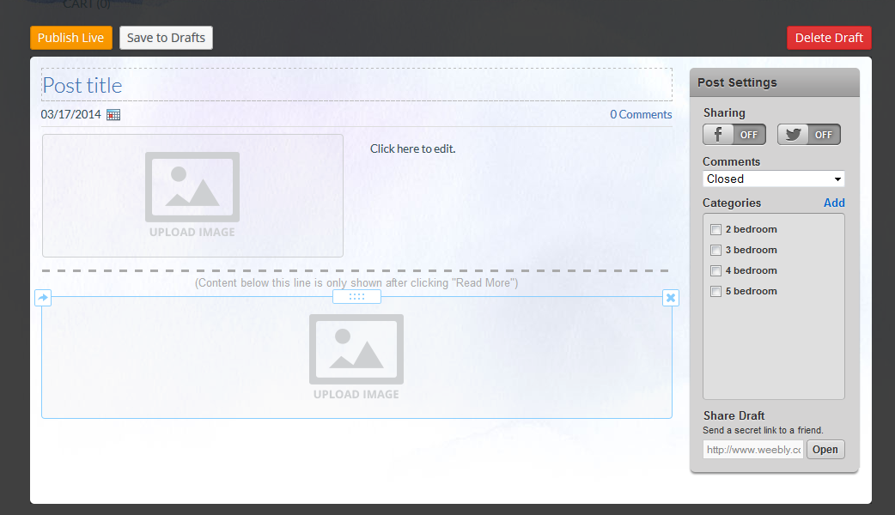  6  5  4  3  2  1
IF THE SELLER/RENTER SENT AN E-MAIL
WITH A LINK TO A WEBSITE:
In E-Mail:
- Forward e-mail to me at missa.uhlman@gmail.com so I can keep it archived.

- Follow link, save feature image to your computer.

- Copy link from browser.
In Weebly:  - Click on “New Post”  - Drag in “Columns” to the body of the post  - Drag “Image” to left column  - Drag “Text” to right column and type this: “For complete listing information and photos, click HERE.”  - Highlight “HERE” in the text you just typed.  - Click the chain link in the black bar above.  - Paste link to property listing in the bar under “Website  URL” and check the box that says “Open link in new  window”.  - Click “Save”.  - Click the “Upload Image” block in the left column and upload a feature image for the property.  - Write a listing title into the “Post Title” line at the top. (I pull something from the first sentence of the description part on the property listing.)  - Select appropriate # of bedrooms under “Categories” on the right.  - Click “Publish Live”. | 7  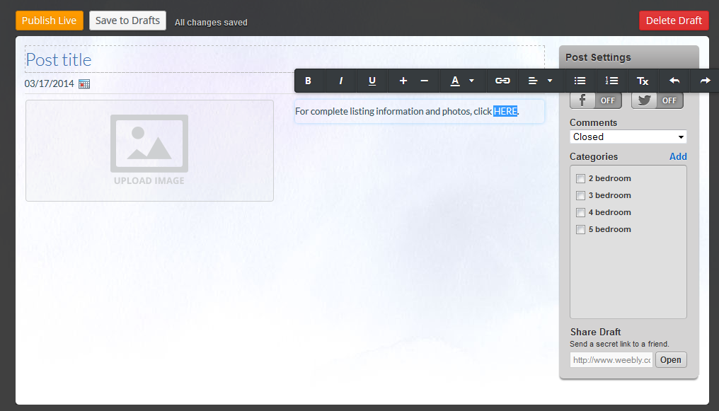  6  5  1, 4  3  2
For all property submissions successfully submitted and posted, send a confirmation e-mail that says something like this:

Hi William,

Thank you for listing your property with Iowa Medical Partners! I have just posted your listing to our housing site.
Please let me know if you have any questions, or if there is anything else that I can do.

Thanks,
Missa Uhlman
Iowa Medical Partners

